1) Download teamviewer in http://thejammers.net/elearning.html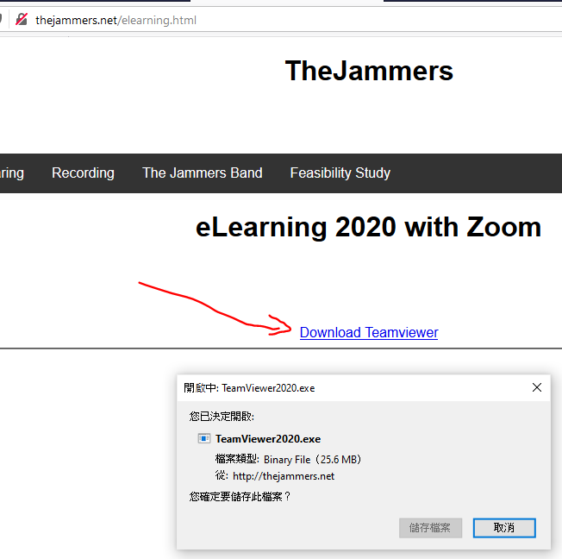2) Execute teamwiewer.exe, choose below 3 option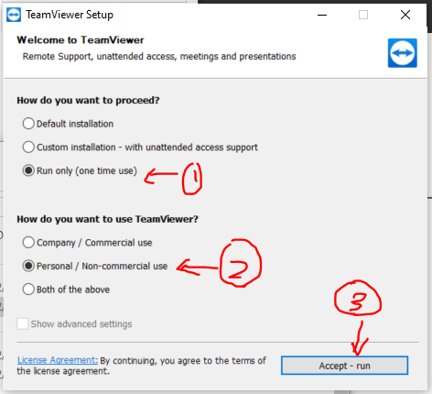

3) Whatsapp below ID and password to Kenneth

